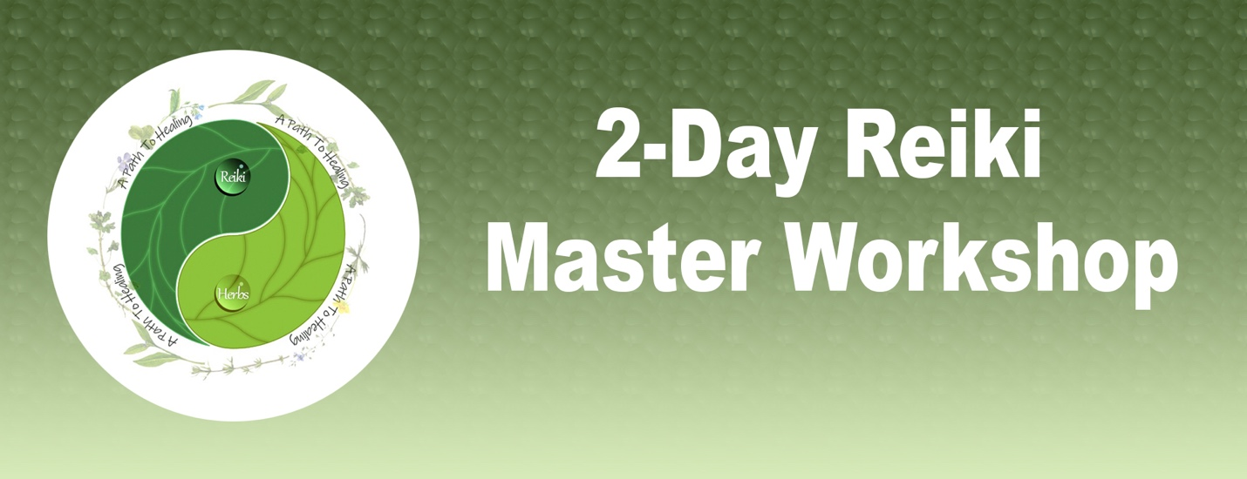

**Advance your Reiki to the Master/Teacher level**

**Class contents**

* Learn how to make a Reiki crystal grid
* Learn to clear the aura with Reiki
* Learn various meditations
* Learn how to attune students
* Meet your Reiki guide

**Workshop also includes**

* Master class manual   
  Attunement to Master/Teacher level
* The Master symbols and how to use them

This workshop is a combination of lecture, discussion, and experience.

**Instructor**

Agnes Prescott, Reiki Master/Teacher, 503-816-5419,

[agnes@apathtohealing.life](mailto:agnes@apathtohealing.life)

**Workshop location @ my house in backyard**

**Date: Check Calendar for Next Available Class**

**Fees** $ 450